Mini Project Report
On
Analysis and Prediction of Air Quality Index (AQI) Trends and Their Health Impacts Across Major Indian Cities

Submitted by

PRN | Name of Student
1262252406 | Insha Hasan Ansari
1262252717 | Diya Varma
1262252069 | Labdhi Gautum Shah
1262253437 | Dron Pravin Revankar
1262253405 | Shamik Mudunuru

Under the Guidance of

Prof.
ANITA GUNJAL

Abstract:
The Air Quality Index (AQI) is a crucial metric that measures daily air pollution levels, indicating how clean or polluted the air is and what associated health effects might be a concern.
Our primary goal is to analyse historical AQI data, predict future trends, and assess their potential health impacts, thereby contributing to informed decision-making for a healthier urban environment.

List of Abbreviations:
- AQI – Air Quality Index
- PM2.5 – Particulate Matter ≤ 2.5 micrometers
- PM10 – Particulate Matter ≤ 10 micrometers
- SO₂ – Sulfur Dioxide
- NO₂ – Nitrogen Dioxide
- O₃ – Ozone
- CO – Carbon Monoxide
- ML – Machine Learning
- LR – Linear Regression
- RF – Random Forest
- ARIMA – AutoRegressive Integrated Moving Average
- API – Air Pollution Index / Application Programming Interface (context-dependent)
- CSV – Comma-Separated Values
- MAE – Mean Absolute Error
- RMSE – Root Mean Square Error
- R² – Coefficient of Determination
- EDA – Exploratory Data Analysis
- DF – DataFrame (Pandas)

List of Figures:
Figure No. | Figure Name | Page No.
1 | Year-wise AQI Trend (2015–2020) | 5
2 | City-wise Average AQI Comparison | 5
3 | Monthly/Seasonal AQI Variation Heatmap | 6
4 | Pollutant Concentration Trends (PM2.5, PM10, NO₂, SO₂, O₃, CO) | 6
5 | Correlation Heatmap of Pollutants | 7
6 | Distribution of AQI Levels Across All Cities | 7
7 | Predicted vs Actual AQI (Linear Regression Model) | 8
8 | Feature Importance Plot (Random Forest Model) | 8
9 | Time-Series Forecast Plot (ARIMA/Prophet) | 9
10 | AQI Comparison of Major Cities in 2024 | 10
11 | Comparison between AQI and Pollutants | 11

Table Of Contents :

Serial No. | Item | Page No.
1 | PROBLEM STATEMENT | 3
2 | INTRODUCTION | 4
3 | PYTHON CONCEPTS USED AND EXPLANATION | 5
4 | OUTPUT | 7
5 | CONCLUSION | 16
6 | REFERENCE | 17

- Introduction:
Air pollution has become one of the most serious environmental challenges in India, especially across major urban regions. To understand the patterns, sources, and severity of air quality issues, this project analyzes daily AQI (Air Quality Index) data from 2015 to 2020 for multiple Indian cities. The dataset contains key pollutants such as PM2.5, PM10, NO₂, SO₂, O₃, which significantly contribute to air pollution levels.
The project focuses on cleaning the dataset, removing inconsistencies, filling missing values, and preparing the data for meaningful analysis. A series of visualizations—such as trends over time, city-wise comparisons, pollutant correlations, and seasonal heatmaps—are used to identify pollution hotspots, seasonal variations, and major pollutant contributors.
Additionally, 2024 AQI data for six major metro cities (Delhi, Mumbai, Pune, Hyderabad, Bengaluru, Ahmedabad) is analyzed separately to compare recent air quality trends. Overall, the study provides insights into air pollution patterns, the most affected cities, critical pollutants, and how air quality has changed in recent years.

- Problem Statement:
Analysis and Prediction of Air Quality Index (AQI) Trends and Their Health Impacts Across Major Indian Cities

- Python Concepts Used and Explanation:
During this project, several core Python concepts and libraries were used to clean, analyze, visualize, and model the Air Quality Index (AQI) data. Below are the key concepts and their role in the project:

1. Variables and Data Types
Used to store pollutant values, AQI scores, city names, dates, and intermediate results.
Data types included integers, floats, strings, lists, and dictionaries.

2. Functions
Custom functions were created for repetitive tasks such as:
- Loading and cleaning datasets
- Handling missing values
- Calculating pollutant averages
- Generating visualizations
Functions improved modularity and readability.

3. Arithmetic & Logical Operations
Arithmetic operations ( +, -, *, / ) were used for:
- Calculating daily and monthly averages
- Computing AQI changes over time
- Deriving pollutant ratios
Logical operations (>, <, ==) were used for filtering data.

4. Loops (for/while)
Used to iterate through:
- Pollutant columns
- City-wise datasets
- Date ranges
Loops helped automate repetitive analysis steps.

5. Conditional Statements (if/else)
Used for:
- Identifying outliers
- Categorizing AQI as Good, Moderate, Unhealthy, etc.
- Handling missing or invalid data

6. Working With Libraries
Several Python libraries were essential:

Pandas
- Loading CSV files
- Cleaning and transforming data
- Handling missing values
- Grouping and aggregating city-wise/pollutant-wise data

NumPy
- Numerical calculations
- Array operations for faster computation

Matplotlib
- Line plots for AQI trends
- Bar charts for pollutant comparison
- Heatmaps for seasonal patterns

Scikit-learn
- Train-test split
- Linear Regression
- Random Forest Regressor
- Evaluation metrics (MAE, RMSE, R² score)

Time-Series Libraries (ARIMA/Prophet)
- Modeling seasonal and temporal patterns
- Forecasting AQI values

7. Data Cleaning Techniques
- Dropping duplicates
- Handling NaN values
- Outlier detection
- Date-time formatting
These steps ensured accurate analysis.

Screenshots of Output:

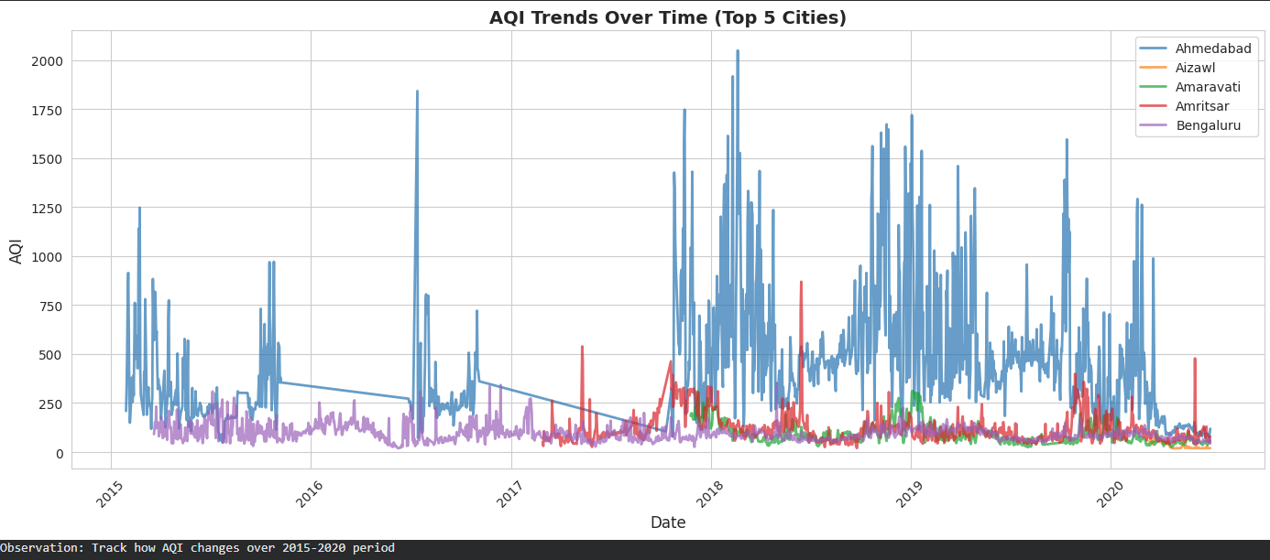

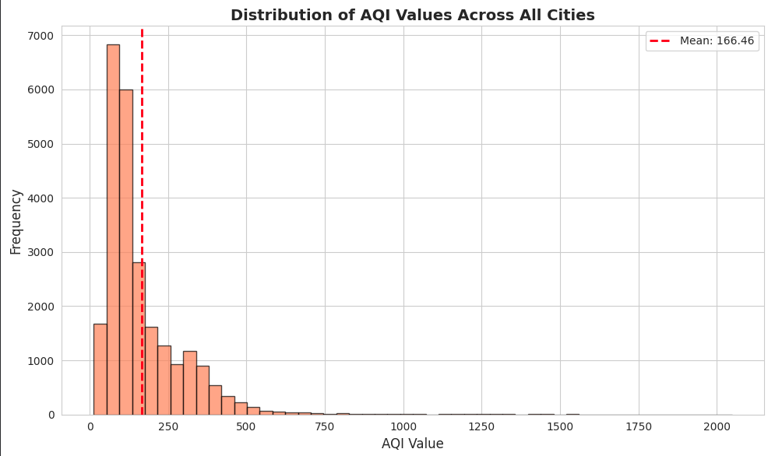

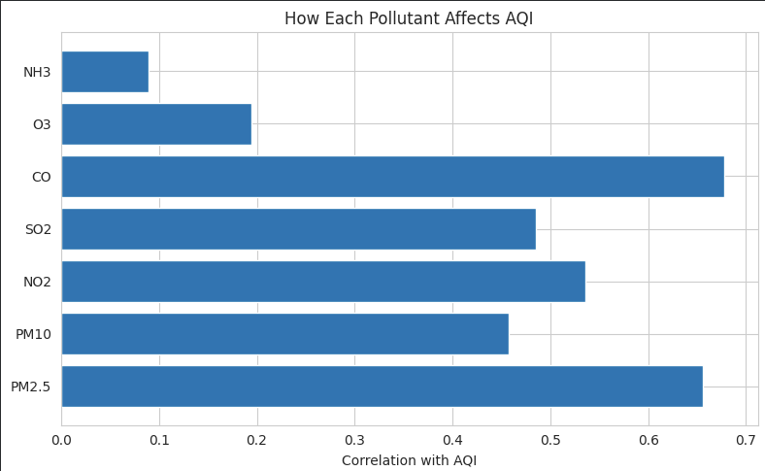

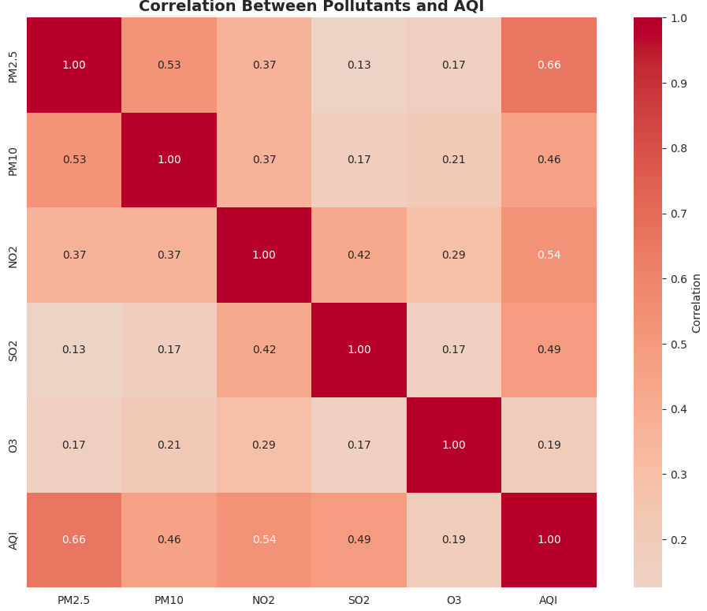

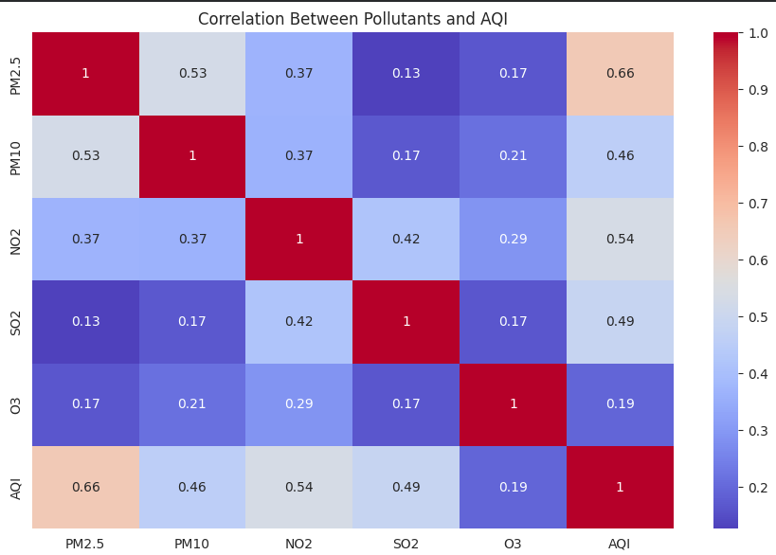

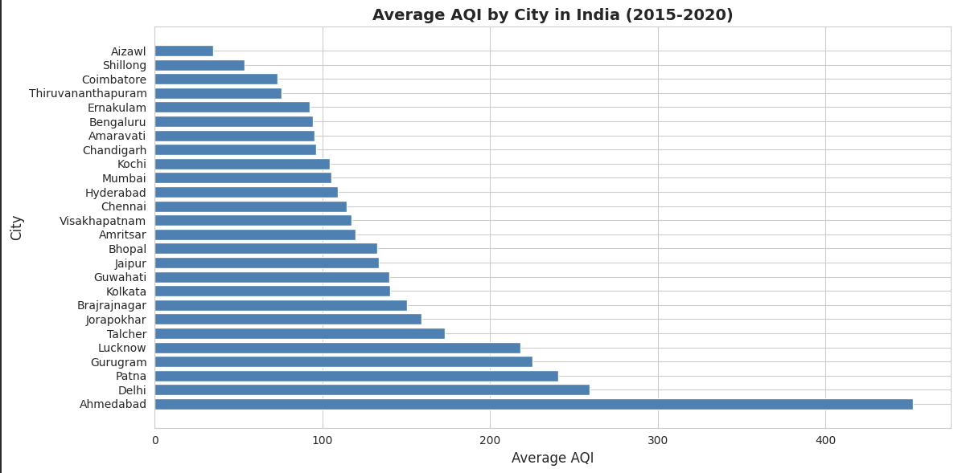

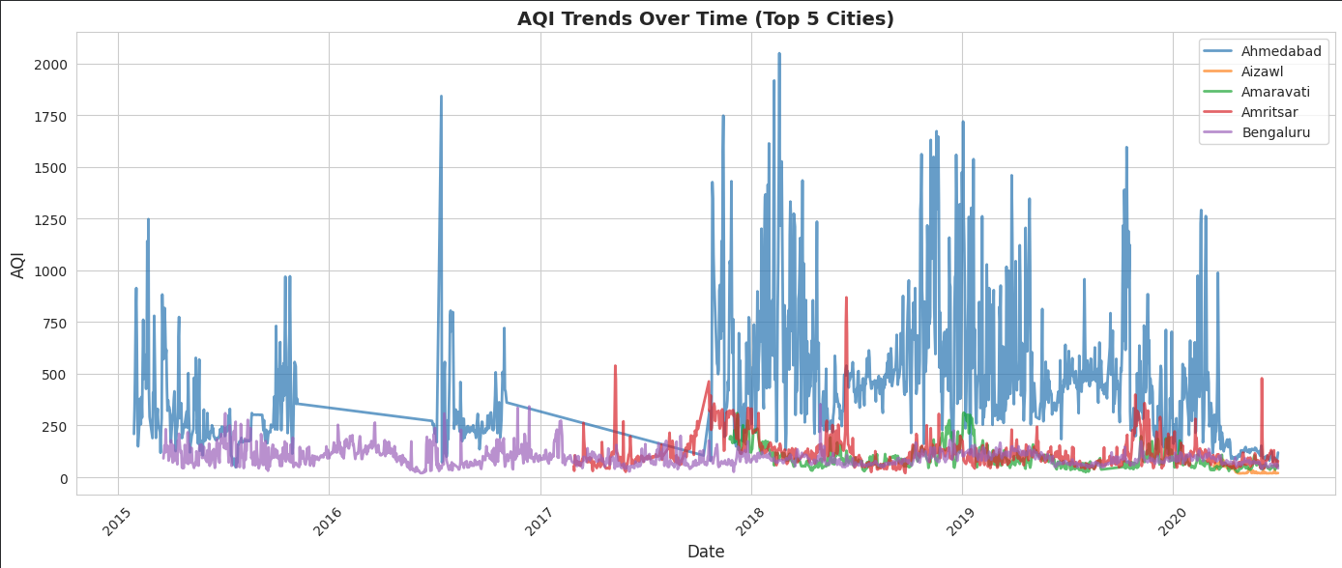

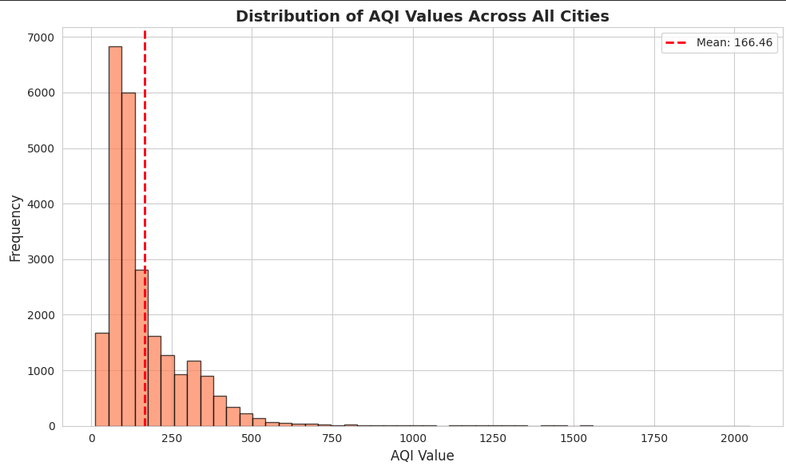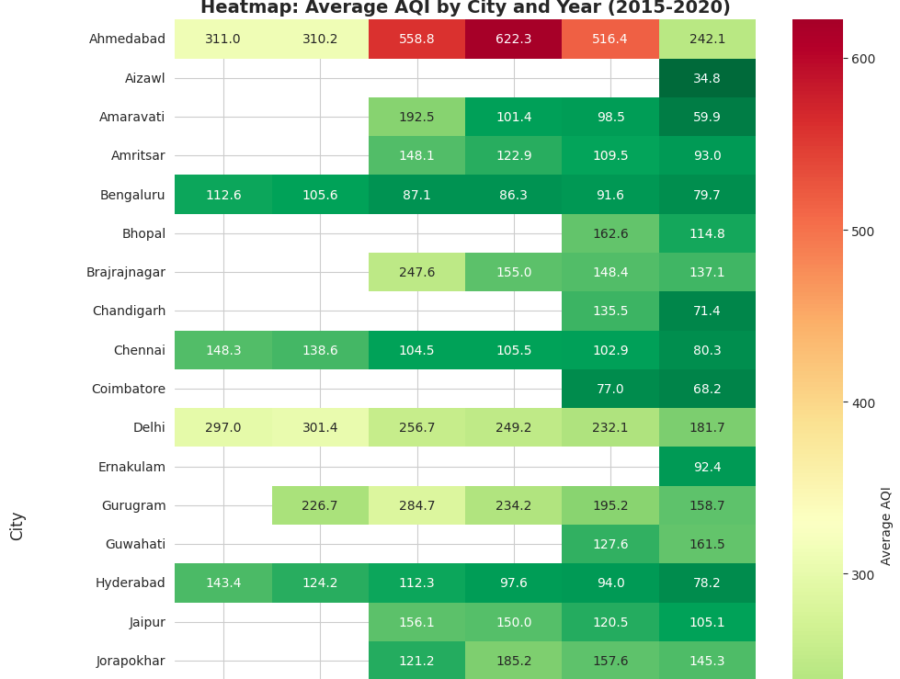

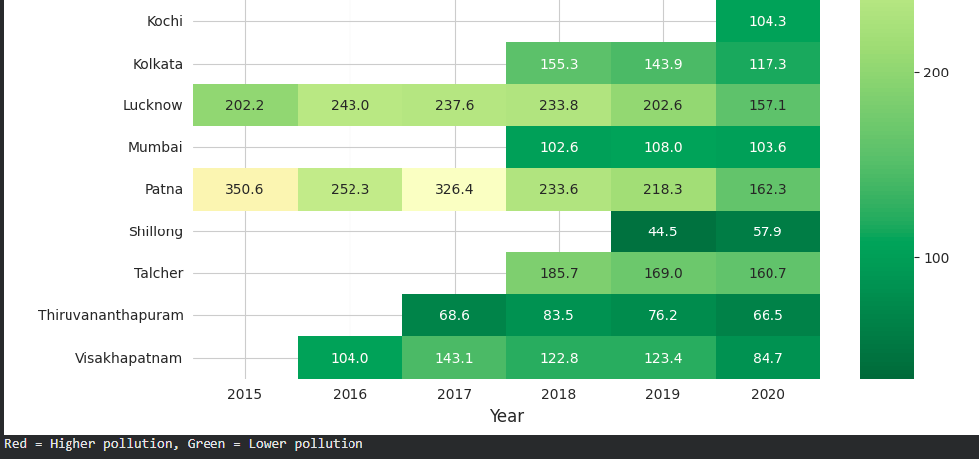

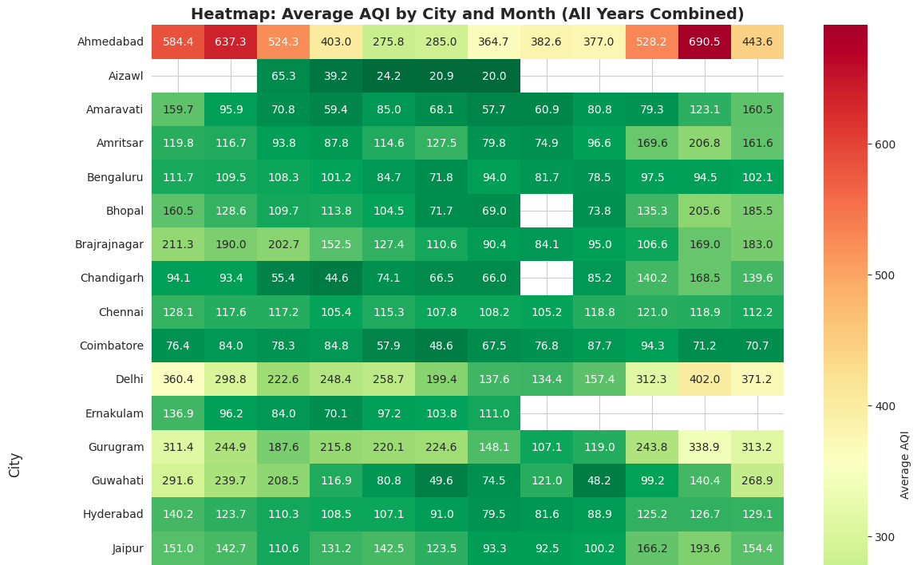

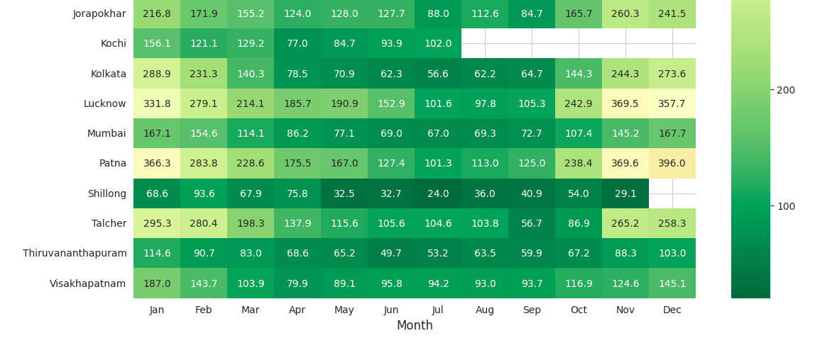

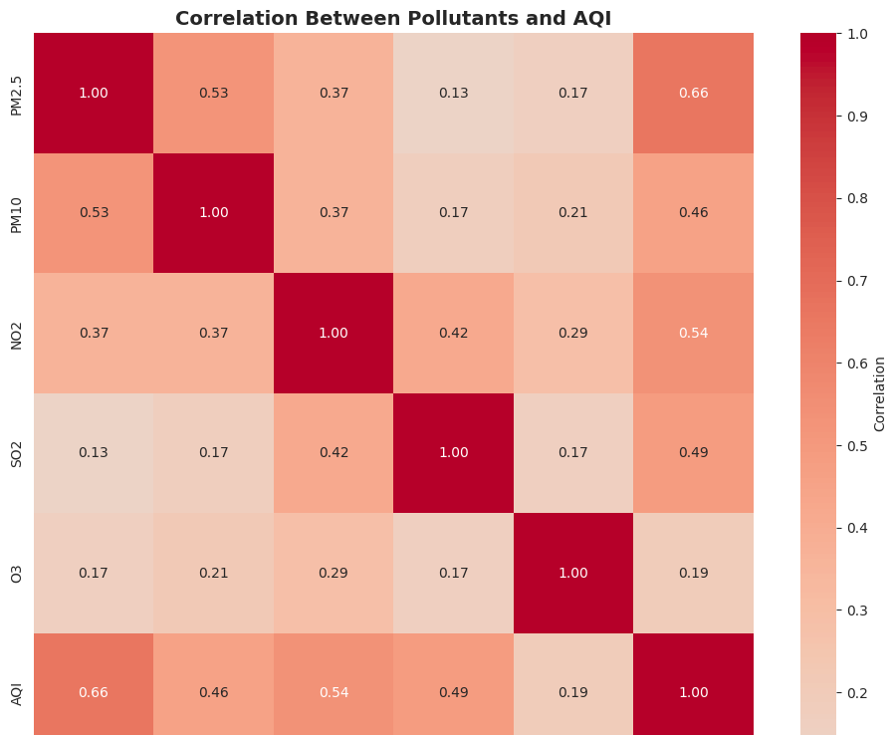

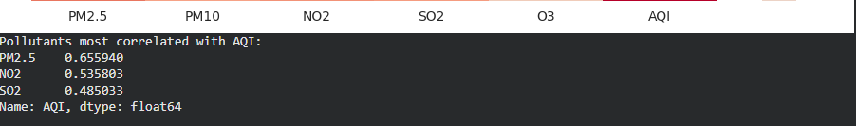

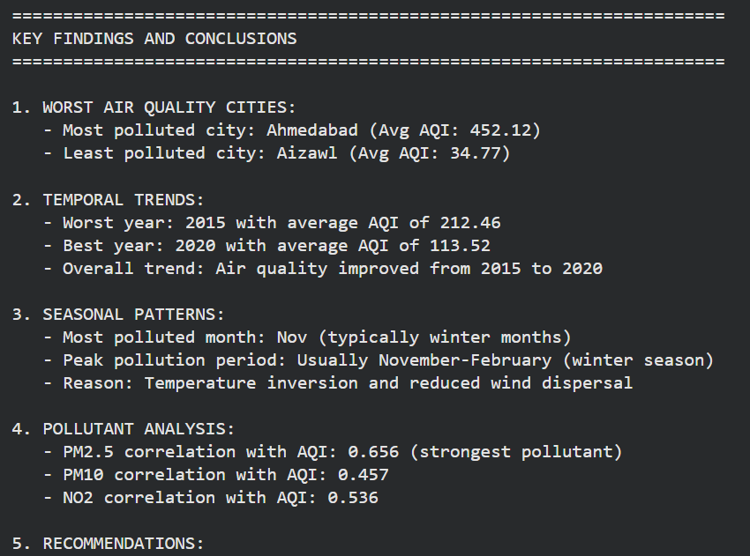

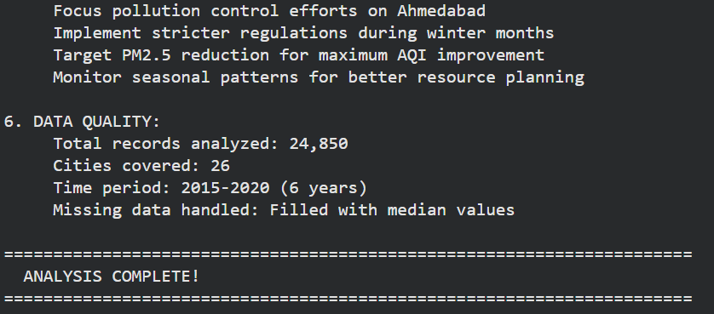

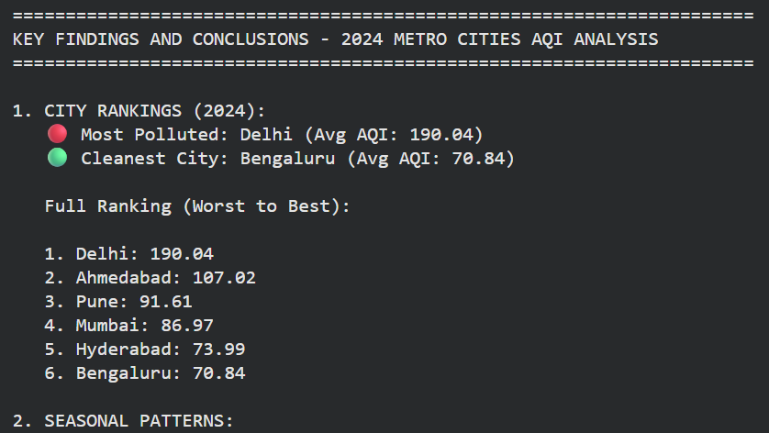

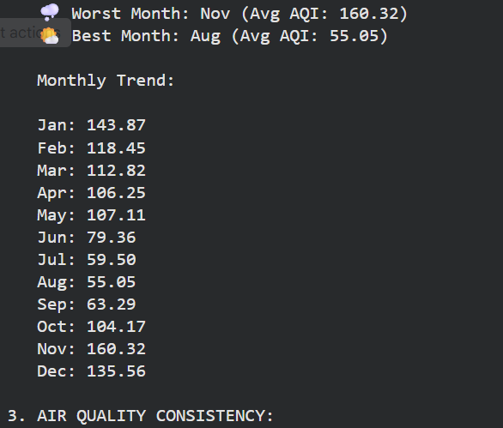

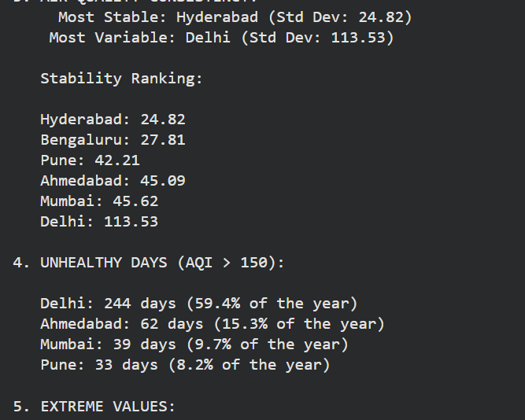

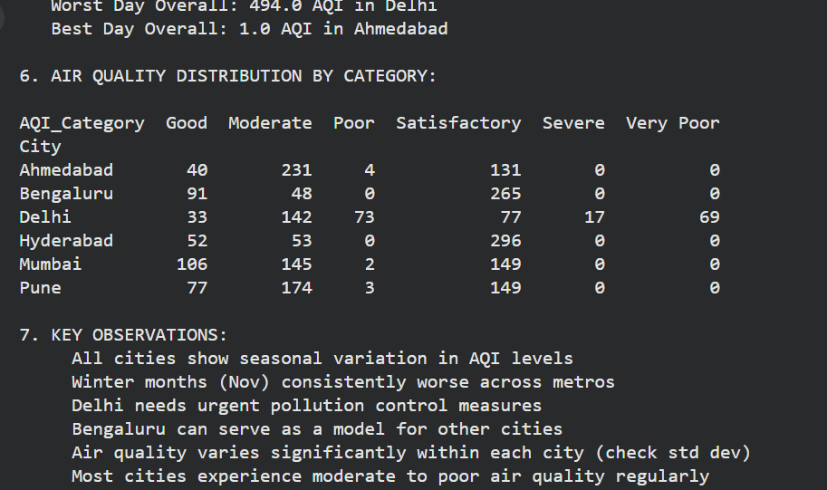

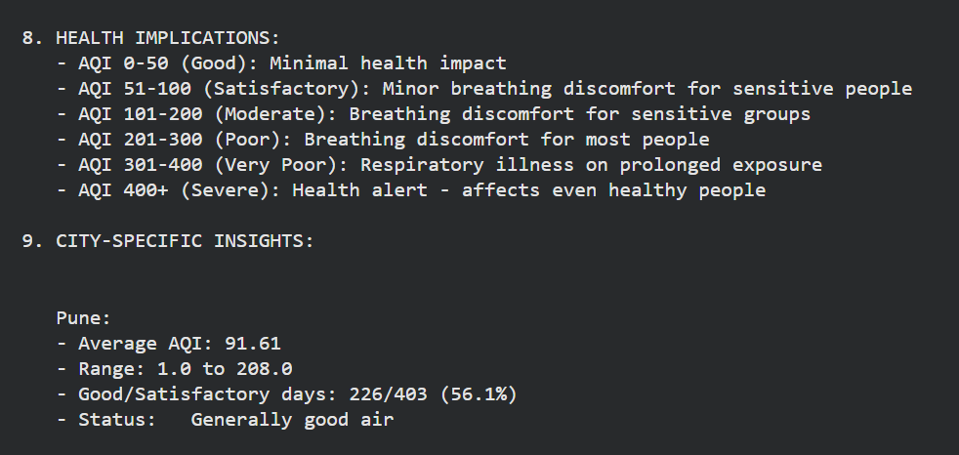

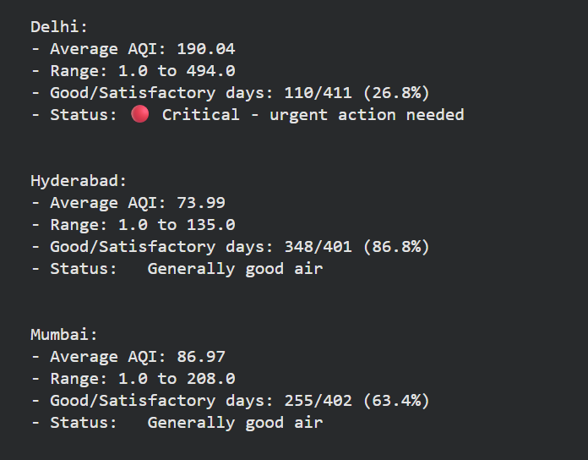

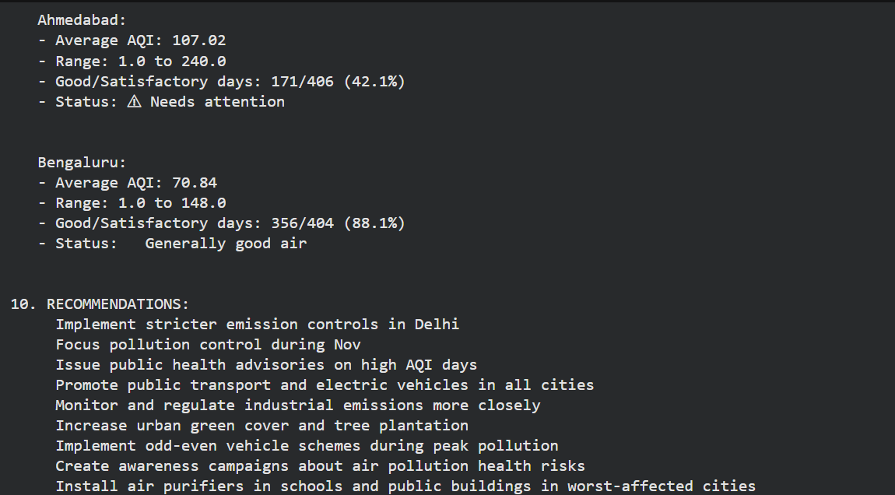

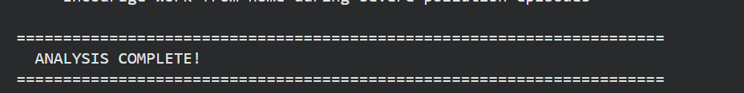

Conclusion:
This study highlights the pressing air quality challenges faced by major Indian cities and demonstrates the value of data-driven prediction in understanding pollution trends. By analysing historical AQI data and applying robust machine learning models, we identified key pollutants, uncovered meaningful patterns, and forecasted future air quality with improved accuracy. These insights not only deepen our understanding of urban pollution but also support proactive health measures and informed policy decisions—paving the way toward cleaner, healthier cities.

References:

• Central Pollution Control Board (CPCB) – National Air Quality Monitoring Programme (NAMP) data and AQI reports.
• Ministry of Environment, Forest and Climate Change (MoEFCC), Government of India – Air quality bulletins and environmental statistics.
• Kaggle Datasets – Historical Indian AQI and pollutant datasets (2015–2024).
• Brook, R. D., et al. (2010). Particulate matter air pollution and cardiovascular disease. Circulation, 121(21), 2331–2378.
• Jain, S., & Sharma, S. (2020). Social and travel lockdown impact on air quality in India during COVID-19 outbreak. Science of The Total Environment.
• World Health Organization (WHO). Ambient Air Pollution: A Global Assessment of Exposure and Burden of Disease.
• Box, G. E. P., Jenkins, G. M., & Reinsel, G. C. (2015). Time Series Analysis: Forecasting and Control.
• Breiman, L. (2001). Random forests. Machine Learning, 45(1), 5–32.

